Watson Assistant Session 2

Using conditional statements, action variables, customer responses (confirmation, number, options)

Note: Do feel free to save and preview how the virtual assistant responses after each step if you want to double check it is working.

Step 1)

On either the existing action or create a new action, select a “conversation step” that you would like to edit or add customer responses. In this case, I will be creating a new action.

I will be asking the user for their account number. For this, I will click on “Define Customer Response” and select “Number”.

The “Assistant says” textbox should look similar to the screenshot below.

Step 2)

Proceed to create a new “Conversation step” as shown in the previous session. In the second conversation step, we will use an action variable to display the user input and to verify that is the correct account number.

, then select the appropriate “Action variables”. I will be using the “action variable” from the previous conversation step.

The “Assistant says” textbox should look similar to the screenshot below.

Afterwards, click on the “Define Customer Response” and select “Confirmation”. This will make sure the user can verify the inputted the correct account number.

The “Define Customer Response” section should look similar to the screenshot below.

Step 3)

As we can see, there is an option for “Yes” and “No”. If a user selects “Yes” or “No”, the virtual assistant would not know how to react. To use the different states, we will use conditional statements.

To do this, create a new “conversational step” and click on the dropdown menu that says “without conditions” and select “with conditions”.

A new section should display which should look similar to the screenshot below.

In this dropdown menu circled, select “No”. This will only be active if the user selects. “No”



As the virtual assistant would be asking the customer re-input the account number, it would be best to notify the user this is happening. For this, in the “Assistant says” textbox type something out to let them know. The textbox should look something similar to this. Graphical user interface, text, application, email

As this would be going back, click on the dropdown menu that says “Continue to next step”. This will allow the user to back to a previous step and have additional options.

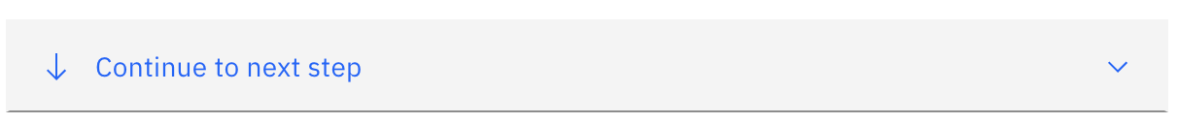

To go back, select the “Re-ask previous step(s)” option.

A modal box will appear proceed to select the steps we require. We will be selecting all the previous steps as it asks the user for an account number and verifies that it is the correct

Proceed to click on “Apply”

The section should look something like this. It is the same as an if-else flowchart.

Step 4)

In this step, we will be using conditional statements and options as if the user has been authenticated.

As we done “No”, we will proceed to “Yes”. Create a new “conversational step” and click on the dropdown menu to select “With Conditions”. It should look like the screenshot below. As we do not need to change the “Yes” variable. We can leave it as it is.

In the “Assistant says” textbox, I have inputted “Your account is verified. Please select what service you want to talk about:” This is a simple prompt for the user understand there are options to select from.

To select “Options” click on “Define customer response” and select “Options”.



After clicking on “Options”, a modal box should appear. This would be where we define options for the user to select from.

I have inputted “Phone” and “Internet”. Click on the “Apply” button to input the options.

The customer responses should look similar to this.

Step 5)

To use the options click on the “without conditions” and select “with conditions”. As the conditions have “Phone” selected, we wont need to edit it

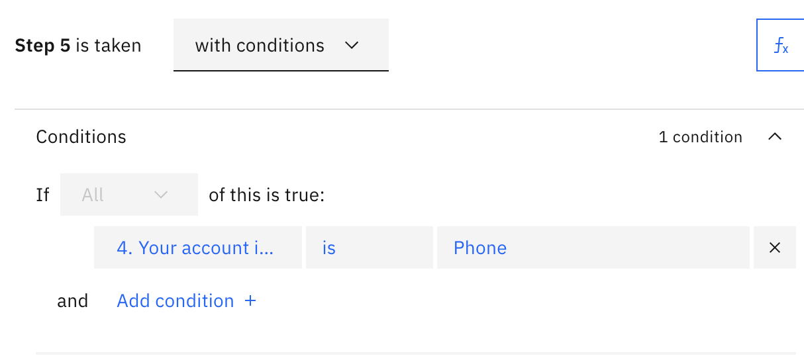

In the “Assistant says” textbox, I will input “You have selected Phone.”

In the “continue to the next step” dropdown menu select “End action”. This would mean the action is ending and the user cannot use the action any further.

Step 6)

To use the options click on the “without conditions” and select “with conditions”. Proceed to select “Internet”.

In the “Assistant says” textbox, I will input “You have selected Internet.”

In the “continue to the next step” dropdown menu select “End action”. This would mean the action is ending and the user cannot use the action any further.

